Copyright Transfer and Statement of Originality

Corresponding author : Dr. Meidiana Dwidiyanti S.Kp., M.Sc.

Manuscript title : Factors Affecting Physical Self-Care Among Patients With Tuberculosis

Affiliation : Balai Pelayanan Kesehatan Masyarakat Magelang

Laboratory/department/institution

Correspondence address

(any change in correpondence address, please inform us)

Mail Address : Jl Jatisari no 22 Perum Jati Raya Indah, Banyumanik, Semarang

Phone/ Mobile Phone Number, : 08164891140

Email Address : mdwidiyanti@gmail.com

STATEMENT

I, the corresponding author, declare that the following matters of submission on the above original paper are correct (please do not circle any)
- This manuscript is our original work and free from plagiarism contents.
- This manuscript has not been published before and is not currently being considered for publication elsewhere.
- Name of supervisor/s is put in the author list as co-author/s, If the manuscript is part of bachelor’s or master’s thesis or intership report.
- Name of student/s is put in the author list as co-author/s, If they made a contribution to the study/ manuscript writing.
- Name of colleague/s or research team member/s is put in the author list as co-author/s, if the made a contribution to the study/ manuscript writing. If there are any authorship dispute, it will be resolved internally.
- The manuscript has been approved by all authors for publication (if there are more than one author)

By signing below, I certifiy all information is true and correct to the best of my knolwedge

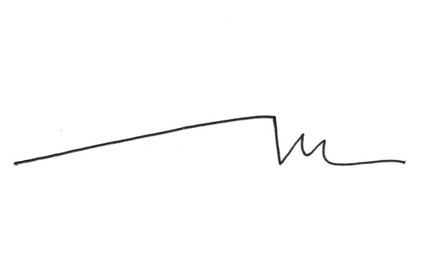
Semarang, 1 Agustus 2019
Corresponding author

(Dr. Meidiana Dwidiyanti S.Kp., M.Sc.)
Please sign this form over IDR 6,000 stamp duty, then scan and upload it when you submit the manuscript in the suplementary document section

