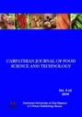
CARPATHIAN JOURNAL OF FOOD SCIENCE AND TECHNOLOGY
journal homepage: http://chimie-biologie.ubm.ro/carpathian_journal/index.html

THE EFFECT OF ANTIOXIDANT AND ANTIBACTERIAL LIQUID SMOKE NANOCAPSULES ON CATFISH FILLET (Pangasius sp.) DURING STORAGE AT ROOM TEMPERATURE AND COLD TEMPERATURE

Fronthea Swastawati^{1*}, Ahmad Ni'matullah Al-Baari², Eko Susanto¹, Lukita Purnamayati¹
¹ Faculty of Fisheries and Marine Science, Diponegoro University, Jl. Prof. H. Soedarto, SH Tembalang, Semarang 50275 Central Java – Indonesia.
²Faculty of Animal and Agricultural Sciences, Diponegoro University, Jl. Prof. H. Soedarto, SH Tembalang, Semarang 50275 Central Java – Indonesia.
* fronthea_thp@yahoo.co.id.

https://doi.org/10.34302/2019.11.4.16

Article history:
Received:
25 March 2018 Accepted:
20 November 2019
Keywords: Catfish; Nanoencapsulation; Liquid smoke; Antioxidant; Antibacterial.
ABSTRACT
The purpose of this study was to determine the effect of antioxidant and antibacterial of liquid smoke nanocapsules on a catfish filet (Pangasius sp.). A combination of liquid smoke (corncob and coconut shell) were processed into nanocapsules using three encapsulan i.e: gum arabic, maltodextrin, and alginate with a ratio of 1/6: 4/6: 1/6 each. Liquid smoke nanocapsules was containing total phenolic content, carbonyl, and Radical Scavanging Activity, there were 3.682 mg GAE/g, 3.439%, and 91.348%, respectively. Liquid smoke nanocapsules was applied to the catfish and stored at room temperature (28ºC±2ºC) and cold temperature (5ºC). Observations were made on days 0, 2, 4, 6, 8, and 10 to parameter PV, TBA, TVBN and TPC. The results showed that liquid smoke nanocapsules could effectively inhibit the oxidation of fat catfish showed with PV and TBA acceptable. Liquid smoke nanocapsules was also capable of inhibiting the activity of microbes, indicated by the value of TVBN and TPC which were still below standard at

all temperatures and long storage time.

Introduction
Catfish were easily damaged by the changes of fat content (oxidation process, lipoxygenase damage, etc), protein and microorganisms (Masniyom, 2011). This damage is indicated by peroxide numbers, TBA (Valdes et al., 2015), TVBN (Tian et al., 2012; Castro, 2012) and TPC (Adilla et al., 2017) which increases during storage. Catfish have high nutrient content especially fat and protein. Catfish contain palmitic acid (24.05%), oleic acid (27.55%), and linoleic acid (7.63%). In addition, catfish also contains non essential amino acids, such as glutamate (3.33%) and essential amino acids, for example lysine (1.82%) (Nurilmala et al., 2015). The high content of fatty acids and amino acids of catfish, resulting in catfish being damaged

165
continuously during cold storage temperatures (Abbas et al., 2005). Therefore, treatment were needed to inhibit catfish damage during storage. Liquid smoke is one of the smoke condensation products in the form of liquid. Liquid smoke is widely used compared to traditional curing methods because it is easy to use and more economical. Liquid smoke also has several compounds such as phenol, acids and carbonyl that acts as an antibacterial and antioxidant (Saloko et al., 2014). Several studies has been done by other researcher using coconut shell liquid smoke to inhibit fish damage, such as tuna (Saloko et al., 2014) tilapia (Ariestya et al., 2016), and catfish (Swastawati, 2008). Other research elaborated the use of corncobs liquid smoke in tilapia (Youssef et al., 2015) and

milkfish (Swastawati et al., 2016); which shows the shelf life of tilapia fillet for 6 days at cold temperature storage (5ºC) (Ariestya et al., 2016). Coconut shell liquid smoke increased the shelf life of mackerel fishballs for 32 hours at room temperature storage (Zuraida et al., 2011). While corncob liquid smoke was able to extend the shelf life of stingrays for 3 days at room temperature storage (Swastawati et al., 2012) and tilapia meatballs for 15 days at cold temperature storage (4ºC) (Youssef et al., 2015). The existence of differences in the capability of coconut shell liquid smoke and corncobs liquid smoke increasing the shelf life of the product encourage the incorporation of these two liquid smokes in application of the product, which is expected to give effect in different shelf life at different storage temperatures. All the previous researcher were only use one raw material of liquid smoke. In this study, we apply combination of two raw materials i.e coconut shell and corncob (50:50) which is hope will give longer shelf life because these mixture of raw material were found to contain higher polyphenols (Anggraini et al., 2017; Swastawati et al., 2014; Lombok et al., 2014; Yuniningsih and Anggraini, 2013).
Polyphenols were volatile bioactive components of liquid smoke. In addition, polyphenols have low and unstable water solubility (Conte et al., 2016). Therefore, a system capable to improve the properties of polyphenols and maintaining polyphenols during storage was required. Nanoencapsulation technology changed liquid smoke in liquid form to a nano-sized powder (nanocapsules) of 1 to 2000 nm Etheridge et al., 2013) has an advantage in the delivery of bioactive components that were efficient in penetrating cells in desired products (Ezhilarasi et al., 2012). Many research were limited to coconut shell encapsulation (Saloko et al., 2014; Ariestya et al., 2016; Novianty et al., 2015; Ali et al., 2014; Saloko et al., 2012). Based on the above description, this study examined the effect of combination liquid smoke nanocapsules (coconut shell and corncob liquid smoke) on
catfish fillet during storage of room temperature and cold temperature.

Materials and Methods
Materials
The materials used in this study were the corncob and coconut shell to produce liquid smoke. Each materials was processed into liquid smoke by pirolisator machine in laboratory of Fisheries and Marine Science Faculty, Diponegoro University, Semarang, Indonesia. Maltodextrin DE 10, arabic gum and Na- alginate were obtain from Multi Kimia Raya Semarang, Indonesia, meanwhile catfish were obtained from the local market in Semarang, Indonesia.

Nanoencapsulation of Liquid Smoke
Nanoencapsulation processed was carried out according to Saloko et al., (2013) with modification in core and coating materials. Coconut shell liquid smoke and corn cob liquid smoke was mixtured with ratio 1:1. Nanoencapsulation was processed by maltodextrin, gum arabic, and Na-alginate with a ratio of 1:4:1 was mixed with a combination of coconut shell and corncob liquid smoke. The solution was homogenized and centrifuged at 3000 rpm for 30 minutes at room temperature. Supernatant was separated and filtered to obtain a solution of pure nanoparticles. The solution of nanoparticles was heated at 50°C in waterbath for 15 minutes and homogenized using a homogenizer at a speed of 4000 rpm for 2.5 minutes. The sample was dried with a spray dryer with inlet temperature about 130ºC, while the outlet temperature about 70°C. The nanocapsules was collected on a sealed bottle and stored at room temperature.

Characteristic of Liquid Smoke Nanocapsules

Analysis of Total Phenolic Content
A amount of 1 gram liquid smoke nanocapsules was diluted to a volume of 25 ml aquadest. 1 ml solution was diluted to 10 ml aquadest. Next 2.5 ml of it’s solution was taken and diluted to 10 ml. After that, 1 ml solution

was put into a test tube and 1 ml saturated Na2CO3 (Merck, Germany) was added and left for 10 minutes at room temperature. Folin ciocalteu reagent (Sigma-Aldrich, USA) 0.5 ml and 7.5 ml of distilled water were added and homogenized by using a vortex for 30 minutes at room temperature. The absorbance of samples were measured at 760 nm wavelength. Phenolic content of samples was calculated as GAE in mg/g dry material (AOCS, 1990).

Analysis of Total Carbonyl
An amount of 1.6 mg of sample was diluted to 10 ml with carbonyl-free ethanol. 1 ml of solution was reacted with 2 ml solution of 2,4- dinitrophenyl-hydrazine (Sigma-Aldrich, USA) with a drop of concentrated hydrochloric acid in ethanol saturated. The mixture was heated in waterbath at temperature 50ºC for 30 min. About 5 ml alcoholic solution of potassium hydroxide (Merchk, Germany) were added when the mixture was cool. Then 2 ml of distilled water was added and measured with a spectrophotometer with a wavelength of 480 nm. Results were calculated by comparing it with the standard curve of acetaldehyde 2,4- dinitrophenylhydrazone (2,4-DNPH) and calculated equivalent of 13.7 ppm acetaldehyde (Sigma-Aldrich, USA) in the sample (Alice et al., 1961).

Radical Scavanging Activity
Radical Scavanging Activity (RSA) was measured by Li and Guo (2010) with modifications. Each sample was reacted with DPPH (Sigma-Aldrich, USA) 0.004 g/ml of ethanol. 0.1 ml of sample was added with 3.9 ml of DPPH and incubated at 28ºC for 30 minutes. Scavanging activity on DPPH radical was measured at 515 nm wavelength. Percent of RSA was measured according to the following equation:
% RSA = {(𝐴𝑐𝑜𝑛𝑡𝑟𝑜𝑙 – 𝐴𝑠𝑎𝑚𝑝𝑙𝑒) × 𝐴^{–4}} × 100% 𝑐𝑜𝑛𝑡𝑟𝑜𝑙
PAH Analysis

Solid-Liquid Extraction
Two grams of freeze-dried fish fillet mixed with a mixture of the 20 ml standard solution with 13 PAH was equal to 0.5 μg.kg-1, considered as internal standards which were homogenized in 40 ml of cyclohexane/ethyl acetate (50:50; v/v) and it was shaked during 30 minutes. The solution was centrifuged at 5000 rpm for 30 min at 0°C. After being homogenized, the liquid part was carefully isolated and evaporated to dryness under a gentle stream of nitrogen. The residue was dissolved in 6 ml of cyclohexane. PAH quantification was the result of the mean of measures carried out on three individual smoked fillets in the same conditions.

Scanning Electron Microscopy (SEM)
Morphology of liquid smoke nanocapsules was observed by using Scanning Electron Microscopy (FEI, Inspect S50). The sample was layered with gold and it was monitored by a magnification of 1,000 times at the voltage of 20 kV.

Application Liquid Smoke Nanocapsules on Catfish
Catfish fillet with a size of 25 x 15 x 1 cm with a weight of approximately 100 grams, was smeared with liquid smoke nanocapsules as much as 1% of the weight of the fillet. After that, catfish fillet was roasted at a temperature of 90°C for 4 hours. Smoke catfish fillet was stored at room temperature (28ºC±2ºC) and cold temperature (5ºC) for 10 days and analyzed every 2 days.

Peroxide Value (PV) Analysis
Peroxide value analysis was conducted by Memon et al., (2010). The sample was dissolved in a mixture of chloroform (Merck, Germany) and glacial acetic acid (Merck, Germany) and added with a solution of potassium iodide (Merck, Germany). The mixture was finally titrated with sodium thiosulfate solution (Merck, Germany) 0.01 M with 1% starch indicator.

Thiobarbituric Acid (TBA) Analysis
TBA analysis was conducted by Molla et al., (2015), 2 ml of 20% trichloroacetic acid (Merck, Germany) and 2 ml of 0.67% thiobarbituric acid (Fluka Chemika, Switzerland) was added to 1 ml of the sample solution. The mixture was heated at 100°C for 10 minutes in waterbath. The mixture was centrifuged at 3000 rpm for 20 minutes. Supernatant containing TBARS absorbance was measured at 532 nm wavelength using a spectrophotometer.

Total Volatil Base Nitrogen (TVBN) Analysis
Total Volatile Base Nitrogen (TVBN) was carried out according Indonesian National Standard 2354.8:2009 (BSN, 2009). Briefly, 25 g samples was weighed and mixed with 75 mL TCA (Merck, Germany) 7%. 1 ml filtrat was put in conway cup of outer chamber which had previously been added 1 mL K2CO3 (Merck, Germany). Another Conway cup of inner chamber was added 1 mL Boric acid and 2-3 drops of indicator (screen metal red) until the color was green. Blanko had been used 1 mL TCA 7%. Conway cup was incubated at 37°C until 2 hours. Conway cup in the inner chamber of blanko was titrated with HCl until the color
was pink. Conway cup of samples titrated with boric acid until the color was equal with blanko.

Total Plate Count (TPC) Analysis
Total Plate Count (TPC) was obtained by Indonesian National Standard 2332.3:2015 (BSN, 2015). Fish samples were diluted into Butterfields Phosphat Buffered (Merck, Germany) with concentration of 10⁴, 10³, and
105. One milliliter of each sample solution was placed into petridisc containing plate count agar (PCA) (Merck, Germany). Petridisc containing samples was incubated with the opposite position at 35ºC for 48 hours. The number of colony were calculated by hand tally counter for the amount 25-250.

Results and discussions 3.1.Characterization of Liquid Smoke Nanocapsules
The content of total phenols, total carbonyl, and RSA of liquid smoke nanocapsules in a row was consecutively 3.682 mg GAE/g, 3.439% and 91.348% (Table 1). Total phenolic content of liquid smoke nanocapsules was influenced by the total phenolic content of liquid smoke and the composition of the coating material. Based on Hardianto and Yunianta (2015) the total phenolic content of corn cob liquid smoke was lower than coconut shell liquid smoke.

Table 1. Characteristics of Liquid Smoke Nanocapsules
Characteristics | Results
Total Phenolic Content (mg GAE/g) | 3.68
Total Carbonyl (%) | 3.44
Radical Scavanging Activity (%) | 91.35
Polycyclic aromatic hydrocarbons (PAHs)
(ppm)
Naphtalen | 286.40
Acenaphtane | 106.35
Phenantrene | 11.70
Phyrene | 30.00
Benzo-α-Antrazene | 67.10
Benzo-α-Phyrene | 47.55

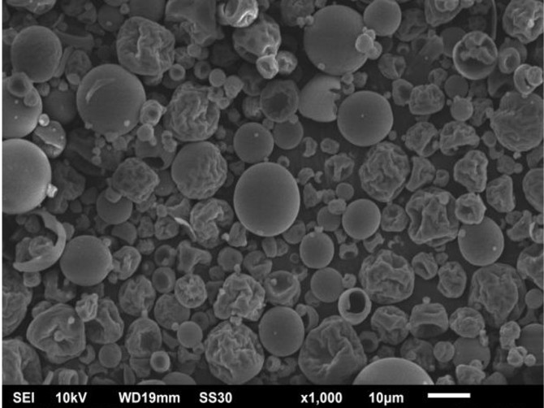

Figure 1. Microstructure of Liquid Smoke Nanocapsules

The composition of the coating material also affected the content of total phenols. The use of the coating material for one portion of alginate composition could trap phenolic content of liquid smoke during the spray drying process. This research was accordance with Novianty et al., (2015) that the encapsulation process of liquid smoke with alginate 1% was able to trap the phenol content with the release of phenol for 20 minutes.
Total carbonyl content of liquid smoke nanocapsules was also affected by carbonyl content of liquid smoke. The carbonyl content of corncob liquid smoke was greater than coconut shell liquid smoke. Because of the corncob liquid smoke contains cellulose degradation products that were more than the liquid smoke coconut shell (Hardianto and Yunianta, 2015). In addition, the alginate composition as a coating material can protect the carbonyl during the spray dryer. Alginate can form a gel (Novianty et al.,2015). Alginate was polysaccharide that contain of homoploymeric mannoronic (M) and guluronic (G) block. The gel characteristic of alginate was affect by M/G ratio (Fertah et al., 2017). This character was used to protect the phenolic content and carbonyl component during nanoencapsulation process. Nanocapsules oxidative capability of liquid smoke was measured by Radical Scavanging Activity. The RSA of liquid smoke nanocapsules was 91.35%. It was indicated that
the coating materials was able to inhibit the oxidation of liquid smoke associated with total phenolic content and total carbonyl, where the component acts as an antioxidant and antimicrobial in food (Leha, 2010).
According to the table 1, it was known that liquid smoke nanoencapsulation contain PAH especially benzo-α-phyrene. Benzo-α-phyrene was known to be carcinogenic and mutagenic to human. Based Swastawati (2008), coconut shell liquid smoke had benzo-α-phyrene contents of
11.351 ppm, while corn cob liquid smoke was not detected (Swastawati et al., 2007). According to the table 1, it showed that the coating material can trap nanocapsules PAH compounds.
Based on morphological observation of liquid smoke nanocapsules (Figure 1), it could be detected that the liquid smoke nanocapsules produced a perfect numerous circle. Novianty et.al.,(2015) showed that the concentration of 1% alginate microcapsules produced liquid smoke morphology with an unbroken sphere. This showed that alginate as a coating material was capable of protecting the liquid smoke during nanoencapsulation process.

Peroxide Value (PV) Analysis
The combination of liquid smoke nanoencapsulation was applied to the catfish fillets and stored at room temperature and cold temperature. The antioxidant and antimicrobial

effects were observed during storage. The number of peroxide value on a catfish fillet was presented in Figure 2. Based on the results obtained, the peroxide value of catfish fillets increased on days 0 to day 4. After that, the peroxide value decreased until 10 days at all storage temperatures. Peroxide value was the number that indicated the degree of damaged oil or fat by oxidation. The oil reacted with oxygen
and form peroxides, especially when it contains unsaturated fatty acids (Panagan, et al.,2011). Catfish fillets had a fat content of 0.12 to 1.42% (Rario, 2015). Catfish fat contains omega-3 (Panagan, et al.,2011) as an unsaturated fatty acid, that potentially forms peroxides due to oxidation.

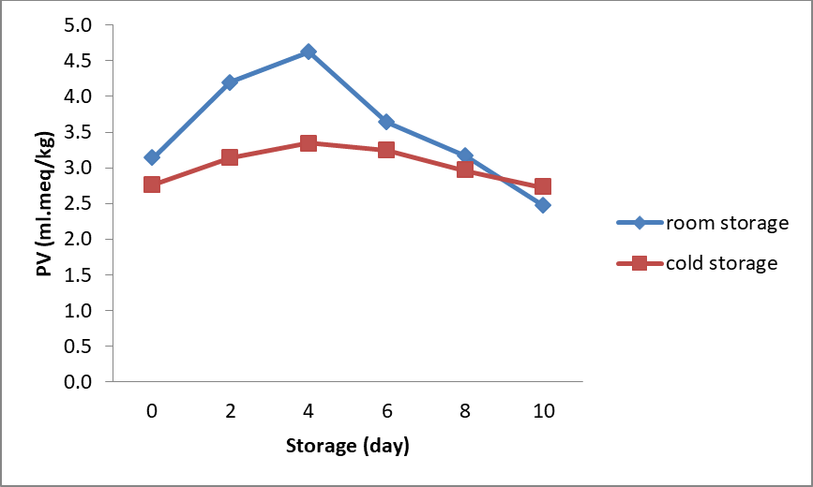

Figure 2. The Peroxide Value of Catfish Fillet Stored at Room Temperature and Cold Temperature

The combination of liquid smoke nanocapsules had a total phenolic content of 3.68% and the RSA of 91.35%, that can inhibit the oxidation process of catfish fillet. The result showed that the storage of catfish fillet for 4 days had a good peroxide value at room temperature and cold temperature, there were 4.70 meq/kg and 3.35 meq/kg, respectively. The peroxide value was decreased for 10 days of storage at room temperature and cold temperature, there were
2.47 meq/kg and 2.73 meq/kg, respectively. The different results were shown by Adebowale et al., (2012) that the catfish storage at room temperature for 21 days obtained peroxide value for 5.12 meq/kg. A maximum limit for foodstuffs peroxide value was 5 meq/kg. This result showed that the catfish fillet after 10 days of storage was feasible for consumption.

Thiobarbituric Acid (TBA) Analysis
The TBA value of catfish fillet during storage was presented in Figure 3. TBA measured the amount of malonadehid which is
the final product of fat oxidation (Piccolo et al., 2014). Based of figure 3, it could be seen that the TBA value of catfish fillet increased until 4 days of storage, for storage of room temperature from
3.53 mg malonaldehid/kg to 4.73 mg malonaldehid/kg. Meanwhile the TBA value of catfish fillet at cold temperature storage were
3.29 mg malonaldehid/kg to 4.05 mg malonaldehid/kg. The TBA value decreased until 10 days of storage, there were 3.21 mg malonaldehyde/kg at room temperature and 2.80 mg malonaldehid/kg at cold temperature. Swastawati et al., (2012) applied the coconut shell liquid smoke on a stingray, showed the TBA value decreased after 6 days of storage. The maximum number of malonaldehyde was 5 mg/kg (Gunsen et al., 2011). This result showed that catfish fillets were still feasible for consumption either on the storage at room temperature or cold temperature until 10 days of storage. The combination of liquid smoke nanocapsules applied to the catfish fillet was able to inhibit the oxidation of fat. The

decreasing of TBA value indicated that the secondary oxidation products formation which
not detected with TBA value (Piccolo et al.,
2014).

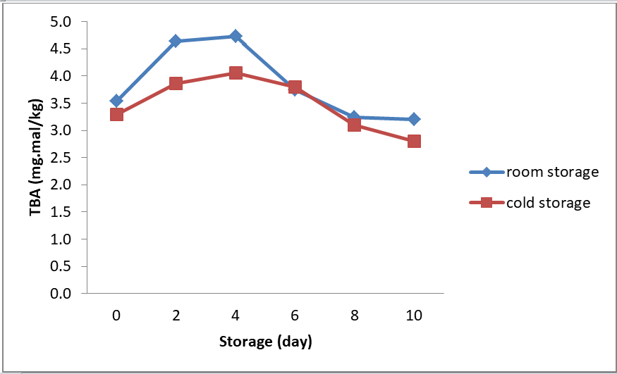

Figure 3. The TBA Value of Catfish Fillet Stored at Room Temperature and Cold Temperature

Total Volatile Base Nitrogen (TVBN)
TVBN analysis measured the declining of fish quality. TVBN measured the protein degradation which is formed dimethylamine, trimethylamine, and ammonia Saloko et al., (2014) that caused by bacterial activity (AOCS, 1990). The TVBN value of catfish fillet during storage was presented in Figure 4. The result showed that TVBN value increased during storage at 10 days. The TVBN value of catfish fillet increased in room temperature and cold temperature of storage, that was 15.08 mgN/100g to 22.58 mgN/100g for room
temperature and 10.95 mgN/100g to 21.51 mgN/100g for cold temperature. This indicated that the longer of storage time, the growth of bacteria in catfish fillet was also increased.
The maximum limit of TVBN value for fish was about 30-35 mgN/100g. This showed that until the 10th day of storage, TVBN value is still below standard, consequently the catfish fillet was fit for consumption. These results related to the total phenolic content of liquid smoke nanocapsules that the phenol content of liquid smoke was able as antimicrobial agents (Saloko et al., 2014).

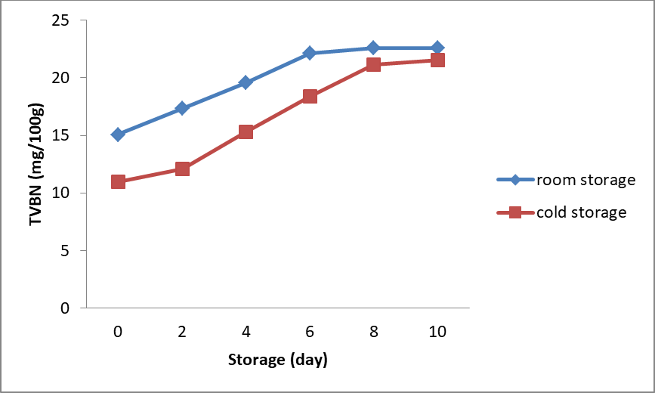
Figure 4. The TVBN Value of Catfish Fillet at Room Temperature and Cold Temperature

Total Plate Count (TPC)
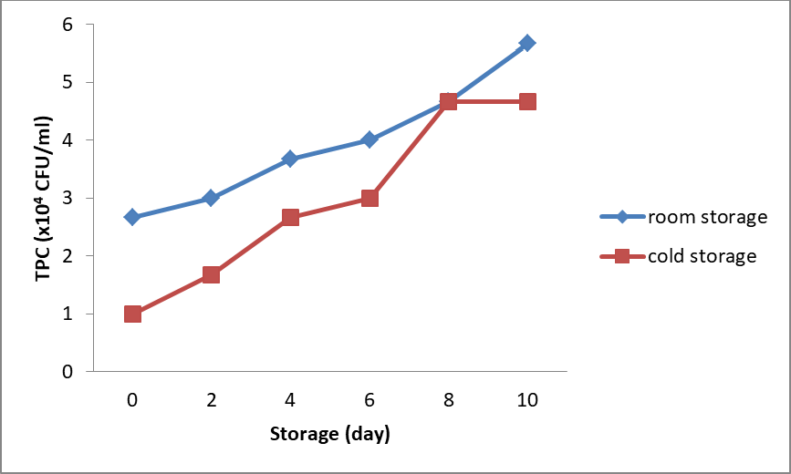
Figure 5. The TPC Value of Catfish Fillet at Room Temperature and Cold

Temperature TPC value of catfish fillet during storage was presented in Figure 5. The result showed that the number of microbial was increased during 10 days of storage. Both room temperature or cold temperature of storage, the number of microbial of catfish fillet were 2.67x10⁴ CFU/g to 5.67x10⁴ CFU/g at room temperature and 1x10⁴ CFU/g to 4.67x10⁴ CFU/g for cold temperature. Based on Indonesia National Standard, the TPC value of fish product was 5x10⁵ CFU/g (BSN, 2009). This result showed that until 10 days of storage, the catfish fillet was still feasible for consumption.
The combination of liquid smoke nanocapsules had total phenolic content that acted as an antimicrobial agent. Zuraida et al., (2011) the coconut shell liquid smoke was able to inhibit microbial growth of fish balls on 20 days of storage with TPC value 1.8 log CFU/g. Ariestya et al., (2016), also showed that the application of liquid smoke microcapsules on Tilapia meat could inhibit microbial growth with the TPC value 26 CFU/g at cold temperatures after 9 days of storage. The microbial growth inhibition because of the phenolic content of liquid smoke.

Conclusions
The liquid smoke nanocapsules application on catfish fillet was able to inhibit oxidation during storage, indicated by the PV and TBA value were under the limit standard until 10 days
of storage. In addition, liquid smoke nanocapsules also able to inhibit microbial activity which was proved by the TVBN and TPC number was below the maximum limit.
The result showed that the liquid smoke nanocapsules was act as antioxidant and antibacterial agent.

References
Abbas, K.A, Mokhtar, A.S., Sapuan, S.M., Mawlood, M.K (2005). Quality deterioration of Malaysian patin fish during cold storage. Journal of Food Agriculture & Environmental, 3(2).
Adebowale, B.A., Ogunjobi, M.A.K., Olubamiwa, O., Olusola-Taiwo, M.O., Omidiran, V.A (2012) Quality improvement and value addition of processed fish (Clarias gariepinus) using phenolic compounds in coffee pulp smoke. International Research Journal of Agricultural Science and Soil Science, 2(13), 520-524.
Adilla, S.N, Utami, R., Nursiwi, A., Nurhartadi,
E. (2017). The effect of nisin from lactococcus lactis subsp. lactis on refrigerated patin fillet quality. IOP Conf. Series: Materials Science and Engineering, 193, 1-7.
Ali, D.Y., Darmadji, P., Pranoto, Y. (2014). Optimation of coconut shell liquid smoke nanoencapsulation using response surface methodology and nanocapsules

characterization, Jurnal Teknologi dan Industri Pangan, 25(1), 23-30.
Alice, T.K, and Peter, E.S., Recovery of some volatile components from mango and guava, Technical Progress Report 128: Hawai, 1961.
Anggraini, S.P.A., and Nurhasiza, T. (2017). Performance optimization of liquid smoke device with agricultural waste material. International Journal of Chemical Technology Research, 10(13).
AOCS. 1990. Oﬃcial methods and recommended practices of the American oil chemists’ society (4th ed.). Urbana, IL: American Oil Chemists’ Society.
Ariestya, D.I, Swastawati, F., Susanto, E. (2016). Antimicrobial activity of microencapsulation liquid smoke on tilapia (oreochromis niloticus (linnaeus, 1758)) meat for preservatives in cold storage (± 5ºC). Aquatic Procedia, 7, 19-21.
Badan Standarisasi Nasional. (2015). Microbiology Analysis Part 3:
Determination of Total Plate Count (ALT) on Fisheries Product. Jakarta. Indonesia.
Badan Standarisasi Nasional. (2015). Chemical Analysis Part 8: Determination of Total Volatil Base Nitrogen (TVB-N) dan Trimetil Amin Nitrogen (TMA-N) on Fisheries Product. Jakarta. Indonesia.
Badan Standarisasi Nasional. (2009). Maximum Limit of Microbe Contamination in Food. Jakarta. Indonesia.
Castro, P., Millan, R., Penedo, J.C., Sanjuan, E., Santana, A., Caballero, M.J. (2012). Effect of storage condition on total volatile base nitrogen determinations in fish muscle extracts. Journal of Aquatic Food Product Technology, 21, 519-523.
Conte, R, Calarco, A., Napoletano, A., Valentino, A., Margaruci, S., Di Cristo, F., Di Salle, A., Peluso, G. (2016). Polyphenols nanoencapsulation for therapeutic applications. Biomolecular Research & Therapeutics, 5(2), 1-13. Etheridge, M.L., Campbell, S.A., Erdman, A.G. (2013). The big picture on nanomedicine : the state of investigational and approved nanomedicine
products. Nanomedicine : Nanotechnology, Biology, and Medicine, 9(1), 1-14.
Ezhilarasi, P.N, Karthik, P., Chhanwal, N., Anandharamakrishnan, C. (2012). Nanoencapsulation techniques for food bioactive components : a review. Food Bioprocess Technol, 1-21.
Fertah, M, Belfkira, A., Dahmane, E. (2017). Extraction and characterization of sodium alginate from moroccan laminaria digitata brown seaweed, Arabian Journal of Chemistry, 10, 707-714.
Gunsen, U., Ozcan, A., Aydin, A., (2011). Determination of some quality criteria of cold storaged marinated anchovy under vacuum and modified atmosphere conditions. Turkish Journal of Fisheries and Aquatic Sciences, 11, 233-242.
Hardianto, L., and Yunianta. (2015). Effect of liquid smoke against chemical properties and appearance fish tuna (euthynnus affinis). Journal of Food and Agro-Industry, 3(4), 1356-1366.
Leha, M.A. (2010). Application of liquid smoke as biopreservatif in foodstuffs. Prosiding Seminar Nasional Basic Science II, 254- 266.
Li, L.Y., Li, L.Q., Guo, C.H. (2010). Evaluation of in vitro antioxidant and antibacterial activities of laminaria japonica polysaccharides. Journal of Medicinal Plants Research, 4(21), 2194-2198.
Lombok, J.Z., Setiaji, B., Trisunaryanti, W. (2014). Effect of pyrolisis temperature and distillation on character of coconut shell liquid smoke. Prosiding of International Conference of Research, Implementation, and Education of Mathematics and Sciences, 87-96.
Masniyom, P (2011). Deterioration and shelf- life extension of fish and fishery products by modified atmosphere packaging. Songklanakarin Journal of Science and Technology, 33(2), 181-192.
Memon, N.N., Talpur, F.N., Sherazi, S.T.H., Banger, M.I. (2010). Impact of refrigerated storage on quality of oil from freshwater jarko (wallago attu) fish. Pakistan Journal

of Analytical & Environmental Chemistry, 11(2), 37-43.
Molla, M.R., Asaduzzaman, A.K.M., Mia, M.A.R., Zeb, M.A., Uddin, M.S. (2015).
Extraction and characterization of oil and lecithin from boal (wallago attu) fish. Journal of Food and Nutrition Research, 3(10), 661-666.
Novianty, H, Darmadji, P., Pranoto, Y., Suharwadji. (2015). Utilization of alginate as an encapsulation model of coconut shell liquid smoke. Marine Research in Indonesia, 40(1), 1-8.
Nurilmala, M, Nurhayati, T., Syukur, A.G., Vitner, Y. (2015). Evaluation of nutritional and color on indonesian and imported patin fish (pangasius sp.,) fillets. Advance Journal of Food Science and Technology, 8(8), 576- 582.
Panagan, A.T., Yohandini, H., Gultom, J.U. (2011). Qualitatif and quantitative analysis of omega-3 unsaturated fatty acid from patin fish (Pangasius pangasius) oil with gas chromatography method. Jurnal Penelitian Sains, 14(4) 38-42.
Piccolo, J., Daniel A. P., Klein, B., Ferreira, L.F., Ruviaro, A.R., Emanuelli, T., and Kubota, E.H. (2014). Oxidative stability of refrigerated fish pates containing loquat seed extract. Ciencia Rural, Santa Maria, 44(9), 1705-1710.
Rario. (2015). Fish fillet catfish processing technology from Central Kalimantan, Indonesia. IOSR Journal of Environmental Science, Toxicology and Food Technology, 9(5), 18-25.
Saloko, S, Darmaji, P., Bambang, S., Yudi, P. (2014). Antioxidative and antimicrobial activities of liquid smoke nanocapsules using chitosan and maltodextrin and its application on tuna fish preservation. Food Bioscience, 7, 71-79.
Saloko, S., Darmadji, P., Setiaji, B., Pranoto, Y. (2012). Structural analysis of spray-dried coconut shell liquid smoke powder. Jurnal Teknologi dan Industri Pangan, XXIII(2), 173-179.
Saloko, S., Darmaji, P., Pranoto, Y., Anal, K. (2013). Encapsulation of coconut liquid smoke in chitosan-maltodextrin based nanoparticles. International Food Research Journal, 20(3), 1269-1275.
Swastawati, F, Boesono, H., Susanto, E., Setyastuti, A.I. (2016). Changes of amino acids and quality in smoked milkfish [chanos chanos (forskal 1775)] processed by different redestilation methods of corncob liquid smoke. Aquatic Procedia, 7, 100-105. Swastawati, F., Boesono, H. and Wijayanto, D. (2014). Antimicrobial activity of corncob liquid smoke and it’s aplication to smoked milkfish (chanos chanos forsk) using electric and mechanical oven. IPCBEE, 67,
109-113.
Swastawati, F., Agustini T.W., Darmanto Y.S., Dewi, E.D. (2007). Liquid smoke performance of lamtoro wood and corn cob. Journal Of Coastal Development, 10(3), 189-196.
Swastawati, F., Susanto, E., Cahyono B. (2012). Sensory evaluation and chemical characteristics of smoked stingray (dasyatis blekeery) processed by using two different liquid smoke. International Journal of Bioscience, Biochemistry and Bioinformatics, 2(3), 212-216.
Tian, X.Y, Cai, Q., Zhang, Y.M. (2012). Rapid classification of hairtail fish and pork freshness using an electronic nose based on the PCA method. Sensors, 12, 260-277. Valdez, H.S, Ezquerra-Brauer, J. M., Marquez-Rios, E., Torres, W.T. (2015). Effect of previous chilling storage on quality loss in frozen (scomberomorus sierra) muscle packed with a low-density polyethylene film containing butylated hydroxytoluene. Food Science and Technology, 35(1), 202-206.
Youssef, M.K.E., Abdel-Gawad, A.S., Darwish, B.M., Hashem, A.M.A. 2015. Assessment of the effect of liquid smokes on the chemical composition and quality attributes of fish balls during chilled storage. Assiut Journal of Agricultural Sciences, 46(4), 50-
64.

Yuniningsih, S., and Anggraini, S.P.A. (2013). Characterization of liquid smoke from coconut shell to be applicated as safe food preservatives for human health. Journal of Agriculture and Food Technology, 3(2), 1-5. Zuraida, I., Sukarno., Budijanto, S. (2011) Antibacterial activity of coconut shell liquid smoke (cs-ls) and its application on fish ball preservation. International Food Research
Journal, 18, 405-410.

Acknowledgments
The authors special thank to Diponegoro University (DIPA PNBP of Diponegoro University – 2016) that was funding this research and financial support to attending The Japanese Society for Fisheries Science (JSFS) 85th Anniversary-Commemorative International Symposium, 22 – 24 September 2017 in Tokyo for presenting this research.

